## Merchant

Demo date: Jun 11, 2024  
Scoping start date: Jun 14, 2024

MSA Signature Date: Jun 26, 2024  
Onboarding Kick Off Date: Jul 3, 2024

[If Exists] Opt Out Date: 01/31/2025  
Go Live Date: Sep 1, 2024

GTM POC: Nick  
Implementation POC: Royce

ERP: None

Tax Integration: No Tax

### 

### Key people at Merchant

### CFO: Tyler F., COO and Co-Founder

### Customer service rep who is really involved: Josh Liss, CEO and Co-Founder

* Account Receivable POC: officialcounslr@gmail.com
* Billing POC: officialcounslr@gmail.com

### Company summary

[Counslr](http://counslr.com) provides text-based mental health support modules to schools and communities and is committed to making mental health care available, accessible, and socially acceptable for all.

Goals (North star)

What is the merchant's goal? What pain are we solving? Why are they buying Tabs?

They are about to move from a standard SaaS model to usage billing and needed a tool to automate the back office work related to AR. Tyler (Co-Founder) was using a combination of Stripe Billing, QBO, and Spreadsheets to track invoicing. Need to streamline the back office work.

They also have a feature request to add invoice paid dates to the CSV export. Ideally, they will export this to upload to Rippling to handle sales commission payouts.  
  
Is there an opt out clause? If so, what is the merchant looking for so that they don’t feel the need to exercise it?

Opt out with 30 days notice ahead of 01/31/2025. Need to have the sales commission functionality in order to not exercise this.  
  
AE Notes

Any important relationship information  
  
1) What is Merchant Temperament?

Tyler is our champion and very easy to work with (i.e. manual workarounds in place until we build towards functionality). Josh will not be main user - he is a little bit of a stickler, but decent guy overall.

2) Is there key POC the buyer/decision maker?

Tyler and Josh are Co-Founders and make every decision together. Tyler is the primary POC for implementation and has been a great partner. Very responsive over Slack DM or the merchant channel.

3) What are the Tabs features the key POC care about?

Invoice scheduling and tracking. Usage data upload. Invoice paid dates for commission payouts. They are moving off from Stripe Billing and slowly migrating all their invoices over to Tabs (starting with the non-annual contract, given those are collected up front and easier to manage. Monthly usage ones are the biggest pain point. They will start sending all new contracts to Tabs as of Aug 12, 2024, and as company renewed, they’ll send to Tabs.

### Billing model

* Info on how merchant bills
  + Monthly, quarterly, or annually (very few).
* How contract is broken up
  + Current contracts in Tabs - Billing by # of employees using the platform per user / per month. (e.g, Kemo Sabe)
  + Flat SaaS fee today - Annual up front, these are not their pain points. They’ll be slower in migrating these over as of Aug (2024) most of them have been already send out
* One off things to know about merchant
  + Small lean team. Tyler currently handles all AR. Only ~20 contracts

### Contract Processing Steps

1. Specific processing requests:
   1. Read the Order Form
      1. You will find the client name there
      2. You will find the order effective date there
      3. You will find the Order Terms there.
   2. Pricing, Service Plan, Payments + Terms are in the document
2. Steps to process
   1. Most of the time, you’d need to create a Customer for them and there’s no GL ledger linked to the account because they are still so small.
      1. Note: The customer email isn’t in the contract, they plan to add that in the future
      2. Tyler also knows how to populate the customer email in the cotract
   2. There’s two dates in the contract, contract signature date and Effective Date.
      1. Use Order Effective Date in Appendix for billing (under the Order Form)
3. Anything to ignore in contracts?
   1. N/A
4. Usage Processing
   1. Please note that Counslr usage is ***always “***in advance”
   2. For processing, please **uncheck** the in arrears box at the bottom of the BT
5. Default Service Term
   1. Use contract info - i.e, 12 months
   2. If None Listed, Ops Default is 1 Year
6. Default Net Payment Terms
   1. Net Terms: See contract - could be Net 7, Net 21, etc
   2. If None, Ops Default is 0
7. Default Billing Frequency
   1. Cadence: Use info from contract - could be monthly, per six month, etc
   2. If None Listed, Ops Default is Monthly
8. How do we handle taxes as a line item?
   1. None
   2. If None Listed, Ops Default is every tax line item becomes a BT

Note:

* If **Billed “Annually”** and you’re seeing a monthly per person, per month dollar amount, see below, please multiplied the $3.50/month by 12 months. The BT for this is now $42/user and this will be 1 invoice for the entire year period.
* 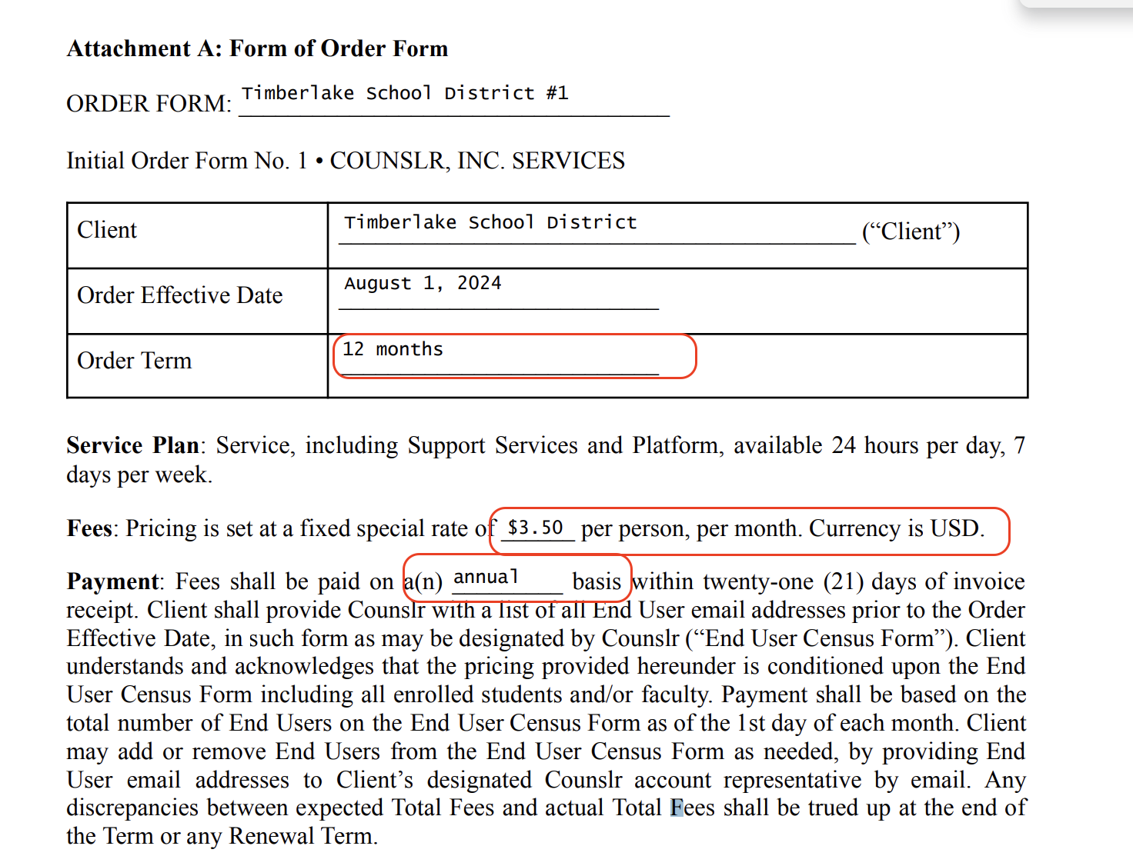

### Events/Usage Processing (if necessary)

* Event based merchant
  + Usage based
  + Use **Number of users** to track

Integration Items Processing (if necessary)

* Use “Sales”
* It doesn’t really matter at this time because they don’t have an GL

Post Processing Communications (if necessary)

* Does Ops Team need to notify anyone on the team re: completion of processing batches in Implementation or Active phase?
* Who needs to be notified and when?
  + In the implementation period, flag for Royce to review
  + **Slack bot notification - please notify the merchant via Slack when the contract is done processing.**

### Customer Information

* Any important information on specifics customers of this merchant
  + Will want to associate Sales Rep who sold the deal to each individual customer. Ideally, have this populated on the invoice as well, so they have visibility into if invoices are being paid.
  + They don’t have an GL and this is not a concern given that they believed that billing software can be the source of truth (Stripe is currently our source of truth, eventually this can be Tabs). They only use QBO once a year during tax season.
    - We tried to push them pretty hard on it and they said they don’t use QBO. At the invoice sent data, we hit an error because their “free trial” with QBO ended. We’ve decided to unlinked QBO to proceed with billing.

### Feature Requests

* CSV of invoice paid dates for commission payouts
  + Extract a CSV with invoice paid dates and commissions for their reps calculated. Simple commission structure
  + One of the main features asks to get this over the line. Currently no finance people on staff and Tyler is doing this in a google sheet the second week of every month.
  + ASAP - sooner we build this, better chance we have of them not opting out

### Rewatch Calls

* June 11th, 2024 - Disco
  + <https://tabs.rewatch.com/video/p7r6k6bobrl0dugx-josh-nicholas-meeting-june-11-2024>
* June 14th, 2024 - Scoping with Royce
  + <https://tabs.rewatch.com/video/slo7bzrse994s8m4-counslr-tabs-deep-dive-june-14-2024>
* June 18th, 2024 - Negotiation and Proposals
  + <https://tabs.rewatch.com/video/43p0lmjff1r8me1g-counslr-tabs-timelines-and-proposals-june-18-2024>